EXPERIMENT NO. 02---Line Coding Techniques



Group Number:
Name:
Roll Number:

____________________________________________________

Design and Simulation Laboratory-Communication Systems
Department of Electronics & Electrical Communication Engineering
Indian Institute of Technology Kharagpur
____________________________________________________

TITLE: Design of Line Coding Techniques
_________________________________________________________________________________
PROBLEM STATEMENT: Using the PN sequence generated in the previous experiment as data:
- Design and implement a circuit for the working of Unipolar Return-to-zero (Unipolar RZ) line coding scheme.
- Design and implement a circuit for the working of Manchester Line coding scheme.
- Design and implement a circuit showing the working of Alternate Mark Inversion (AMI).
- Implement an MLT-3 line coding technique in MATLAB for a stream of bits of digital data in software.
_________________________________________________________________________________
KEY COMPONENTS: IC7418(AND gate), IC7432(OR gate), IC7486(XOR gate), IC7404(NOT gate), IC74164 (8-bit shift register), digital oscilloscope, function generator, breadboard, connecting wires, power supply.
<Add more as necessary>
BRIEF THEORY & BACKGROUND:
The experiment aims at designing circuits for implementing various line coding schemes for a given digital data. Line coding techniques convert digital data to baseband digital signals, then transmit them over a channel. Line encoding schemes require certain parameters to be satisfied: must have minimal complexity in terms of its circuital design, transmitted power of the signal must be low as possible, high tolerance level to the distortions introduced at the receiver. Also, clock synchronisation at the receiver is of paramount importance, dedicating a separate timing circuit at the transmitter and the receiver for this purpose is impractical. Hence, the timing information must be embedded along with the encoded signal such that it could be recovered at the receiver.
Why go for line coding?
There exist numerous rationales for employing line coding. Each of the line patterns under consideration presents distinct advantages, which encompass one or more of the subsequent benefits:
- Signal Integrity: Various distortions may be introduced into the signal due to the channel. Line coding addresses these problems by encoding digital data in a manner that reduces vulnerability to errors arising from noise and interference. Through strategic line code design, receivers can more effectively distinguish between legitimate signal transitions and erratic fluctuations.
- Synchronization: Line coding incorporates clock synchronization details to aid the receiver in accurately interpreting signal transition timing. This guarantees precise retrieval of the original data from the received signal. Accurate synchronization is essential to prevent data misinterpretation and to uphold communication integrity.
- Efficient spectrum utilization: In communication systems, optimizing bandwidth usage is crucial. Line coding aids in spreading signal energy across a wider frequency range, thus maximizing spectrum utilization. This becomes particularly significant for high-speed communication links operating within constrained bandwidth.
- DC component removal: Certain communication channels might impose restrictions on transmitting signals with substantial DC component. Line coding methods can be employed to ensure a balanced dispersion of positive and negative voltage levels in the transmitted signal, mitigating concerns associated with DC drift (baseline wander) and bias. Baseline wander shifts the position of the signal waveform relative to the detector threshold and leads to severe erosion of noise margin.
- Error detection and correction: Specific line coding schemes integrate error-detection and error-correction mechanisms. These functions empower the receiver to detect and potentially rectify errors that might arise during transmission. Such capabilities are vital for preserving the precision of transmitted data, particularly over error-prone communication channels.
Line coding schemes are of 5 types. They are:
- Unipolar Line Coding: It is analogous to a simple on-off keying scheme. It employs a single voltage level to denote binary values. Usually, one is represented by a positive or negative voltage level, while zero is indicated by the absence of a signal (no voltage or a low voltage level). Some examples include Unipolar NRZ and Unipolar RZ.
- Polar Line Coding: Polar coding employs both positive and negative voltage levels to symbolize binary values, effectively handling the DC component concern inherent in unipolar coding. Some examples include Polar NRZ-L/NRZ-I, Polar RZ and Manchester coding.
- Bipolar Line Coding: Bipolar coding, akin to polar coding, utilizes positive and negative voltage levels, while also incorporating zero voltage level. Such a signal is also called a duo-binary signal. Some examples include AMI (Alternate Mark Inversion) and Pseudoternary coding
- Multi-transition Line Coding: It seeks to intensify the frequency of signal transitions, aiding in clock recovery and synchronization.
- Multi-level Line Coding: Multilevel coding employs more than two voltage levels to convey multiple bits simultaneously. While this can enhance data rate, it necessitates superior signal quality and can exhibit heightened susceptibility to noise. Some examples include 2B1Q (two binary, one quaternary) and 8B6T (eight binary, 6 ternary).
The first three schemes can be further subclassified into non-return to zero (NRZ) and return to zero (RZ) schemes. In a non-return to zero scheme, if a signal uses positive or negative voltage to represent a binary digit, the voltage level remains the same during the whole bit period (i.e., one whole clock period). However, in a return to zero scheme, the voltage must drop to zero in the middle of the bit period.
Advantages/Disadvantages of each Line coding scheme and their core usage??
<To-do> In your final writeup, comment on the applications of Line coding in communication systems and describe the application in a few words

EXPECTED OUTCOMES:
- Unipolar-Return-2-Zero: <<Complete this with representative figure>>
- Manchester coding divides the bit period into halves. The voltage maintains one level during the first half, then shifts to the other level in the second half. A binary one is indicated by a positive pulse in the first half followed by a negative pulse in the second, and a binary zero is denoted by a negative pulse followed by a positive one. This technique, often termed bi-phase encoding due to both polarities within each bit, enables the receiver to identify transitions at the bit midpoint. A positive-to-negative shift signifies a binary one, while a negative-to-positive shift signifies a binary zero. Design a circuit that achieves Manchester coding on the previously generated 31-bit PN sequence using the available digital ICs.
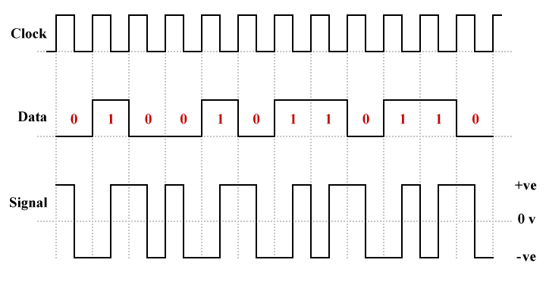
Fig 1: Manchester Encoding

- Alternate Mark Inversion (AMI) employs alternating positive and negative voltages to denote logic high (binary one), while zero voltage represents logic low (binary zero). Although AMI is technically an NRZ line coding scheme itself, it was developed as an alternative to other NRZ schemes. Utilizing the 31-bit PN sequence generated in the previous experiment as data, design and implement a circuit showing the working of AMI line coding technique and comment on it's working.
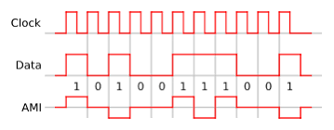
Fig 2: AMI Encoding

- Multilevel transmit-3 is a multilevel level differential line coding scheme where 3 levels (positive, negative and zero) are used to represent binary data. The line coding scheme follows the following rule depending upon the current logic level:
- For any current logic level, if the next logic level is low, there is no transition in the encoded signal i.e., if a binary 1 is followed by a binary 0, then there is no transition in the signal level.
- If the current signal level is non-zero and the next bit is logic high, then the signal will transit to zero level i.e., if a binary 1 is followed by a binary 1, then the signal level of the later binary one would transit from a signal high level to the zero level.
- If the current signal level is zero and the next bit is logic high, then the signal will transit to the level opposite to the last non-zero signal level. Fig 3 explains the working of a MLT-3 encoding of a data sequence.
Using MATLAB, implement the MLT-3 encoding scheme for a stream of 10-100 bits of digital data and comment on the uses of multilevel encoding schemes in communication systems.
Note: Choose the stream size appropriately so that the simulation results (Fig. files) can capture a sufficiently large and rich pattern with the line coded stream.
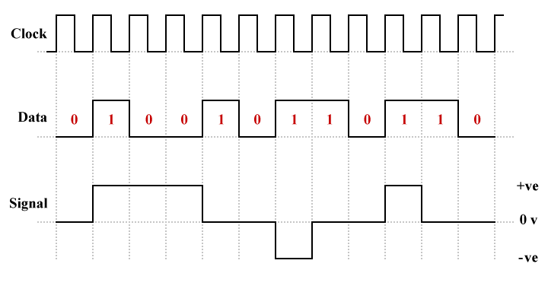
Fig 3: MLT-3 Encoding Scheme for binary data stream
For software parts:
- Export the DSO data, i.e., time series in .csv format and plot it in MATLAB.
- Write a MATLAB Code for MLT-3 encoding scheme whose functioning has been explained above. Plot the input binary data with the encoded version and comment on the advantages/disadvantages of using such a scheme in the communication system.
For Design parts <CHALLENGE [optional]>
- Extend the idea of 1-level AMI, where ‘1’ indicates “memory” that the line coder needs, to a 2-level AMI. Present necessary plots and then present a design of a circuit to realize the 2-level AMI. Comment on how you would extend the idea to a k-level AMI scheme.

ACKNOWLEDGEMENTS:
Mention (enumerate) all references including private communication, reference papers, public articles, etc. Look up online resources to understand how references are cited.

